|  |  |
| --- | --- |
| Ex. No. 1 | **BMI Calculator using Basic View Elements** |
| **Date of Exercise** |  |

**Aim**

To write a Kotlin program to develop a BMI calculator using basic view elements.

**Program**

**Activity Code**

import android.os.Bundle  
import android.widget.Button  
import android.widget.EditText  
import android.widget.TextView  
import androidx.activity.enableEdgeToEdge  
import androidx.appcompat.app.AppCompatActivity  
  
class MainActivity : AppCompatActivity() {  
 override fun onCreate(savedInstanceState: Bundle?) {  
 super.onCreate(savedInstanceState)  
 *enableEdgeToEdge*()  
 setContentView(R.layout.*activity_main*)  
 val t1 = findViewById<EditText>(R.id.*t1*)  
 val t2 = findViewById<EditText>(R.id.*t2*)  
 val b1 = findViewById<Button>(R.id.*b1*)  
 val t4 = findViewById<TextView>(R.id.*t4*)  
  
 b1.setOnClickListener**{** val ht = t1.*text*.toString()  
 val wt = t2.*text*.toString()  
  
 if(ht.*isNotEmpty*() && wt.*isNotEmpty*()) {  
 val height = ht.*toFloat*()  
 val weight = wt.*toFloat*()  
 val bmi = weight / (height * height)  
  
 val status = when {  
 bmi < 18 -> "Underweight"  
 bmi in 18.0..24.9 -> "Normal"  
 bmi in 25.0..29.9 -> "Overweight"  
 else -> "Obese"  
 }  
  
 val bmiResult = String.*format*("Your BMI is: %.2f\nStatus: %s", bmi, status)  
 t4.*text* = bmiResult  
 }  
 else{  
 t4.*text* = "Please enter valid height and weight"  
 }  
 }}  
}

**XML code**

<?xml version="1.0" encoding="utf-8"?>  
<LinearLayout xmlns:android="http://schemas.android.com/apk/res/android"  
 xmlns:tools="http://schemas.android.com/tools"  
 android:layout_width="match_parent"  
 android:layout_height="match_parent"  
 android:orientation="vertical"  
 android:padding="16dp"  
 tools:context=".MainActivity">  
  
 <TextView  
 android:id="@+id/t"  
 android:layout_width="wrap_content"  
 android:layout_height="wrap_content"  
 android:text="BMI Calculator"  
 android:textSize="24sp"  
 android:textStyle="bold"  
 android:layout_gravity="center_horizontal"  
 android:paddingBottom="16dp"/>  
  
 <EditText  
 android:id="@+id/t1"  
 android:layout_width="match_parent"  
 android:layout_height="wrap_content"  
 android:hint="Enter your Height"  
 android:inputType="numberDecimal"  
 android:padding="10dp"/>  
  
 <EditText  
 android:id="@+id/t2"  
 android:layout_width="match_parent"  
 android:layout_height="wrap_content"  
 android:hint="Enter your Weight"  
 android:inputType="numberDecimal"  
 android:padding="10dp"/>  
  
 <Button  
 android:id="@+id/b1"  
 android:layout_width="match_parent"  
 android:layout_height="wrap_content"  
 android:text="Calculate"  
 android:padding="10dp"  
 android:layout_marginTop="16dp"/>  
  
 <TextView  
 android:id="@+id/t4"  
 android:layout_width="match_parent"  
 android:layout_height="wrap_content"  
 android:text=""  
 android:textSize="18sp"  
 android:layout_marginTop="16dp"  
 android:layout_gravity="center_horizontal"/>  
  
</LinearLayout>

**Output Screenshots**

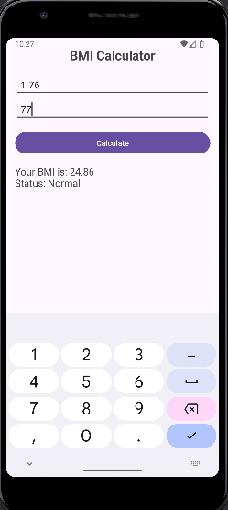

**Result**

Thus the code is executed successfully and the output is displayed in the console window.